Python slicing:

Small piece of something larger

In python strings are iterable data_types

In string every character is itself a element or we can say string is iterable and index 0 to soon..

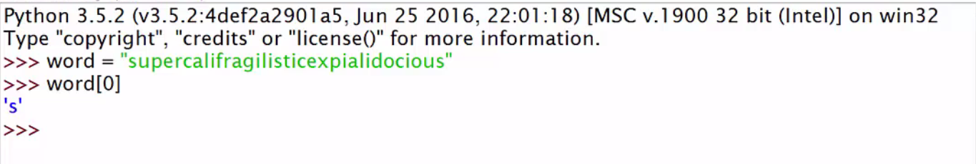

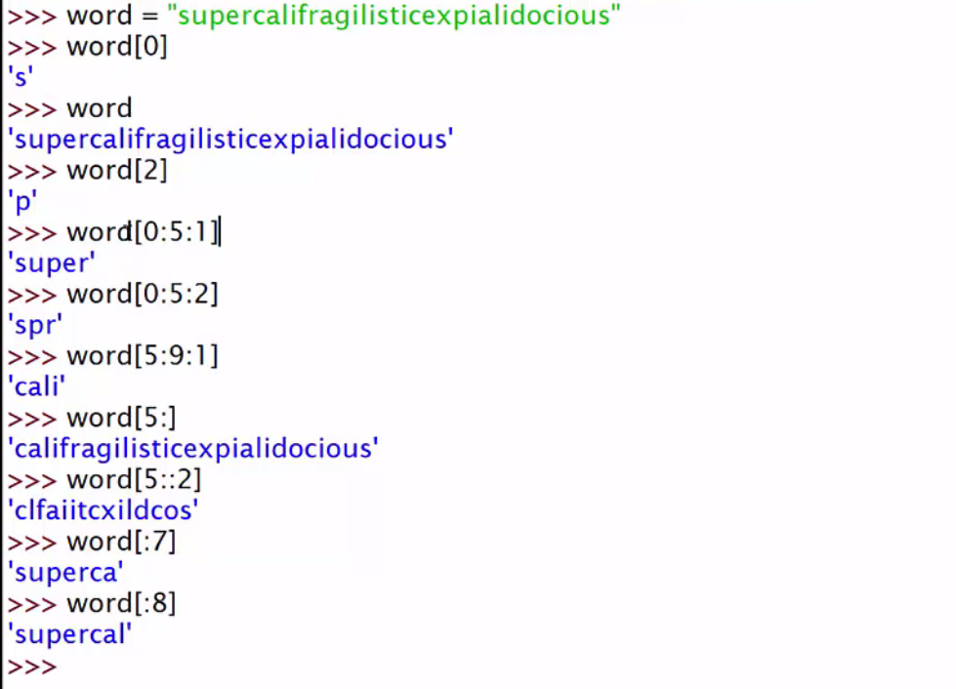

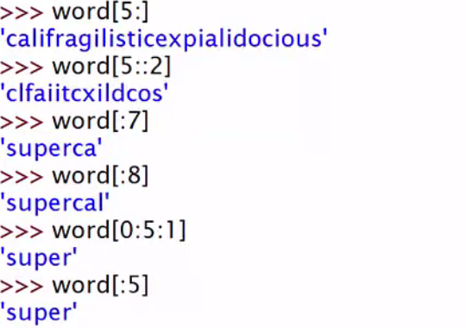



Minus naal step reverse order ch chalda va kee in mind

-1 means 1 step reverse and -2 means for 2 step reverse

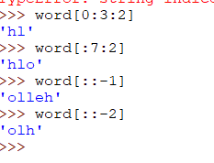

Slicer Part -2:

Counting through end

